Binh Dinh, December 19th, 2022
No: 57/NQ-HĐT
RESOLUTION
The regular meeting of the Council of Quy Nhon University
for the fourth quarter of 2022, term 2020-2025

COUNCIL OF QUY NHON UNIVERSITY
Based on the Law on Higher Education dated June 18, 2012, and the Law amending and supplementing certain provisions of the Law on Higher Education dated November 19, 2018;
By Government Decree No. 99/2019/NĐ-CP dated December 30, 2019, which provides detailed regulations and guidelines for the implementation of certain provisions of the Law amending and supplementing certain provisions of the Law on Higher Education;
Referring to the decision No. 2019/QĐ-BGDĐT dated July 20, 2020, of the Minister of Education and Training recognizing the Council of Quy Nhon University for the 2020-2025 term, as well as decision No. 2021/QĐ-BGDĐT dated July 20, 2020, of the Minister of Education and Training recognizing the Chairman of the Council of Quy Nhon University for the 2020-2025 term;
By the Organization and Operation Regulations of Quy Nhon University issued together with Resolution No. 12/NQ-HĐT dated December 8, 2020, of the Council of Quy Nhon University;
Based on Minutes No. 56/BB-HĐT dated December 17, 2022, regarding the regular meeting of the fourth quarter of 2022 of the Council of Quy Nhon University.

RESOLUTION:
Article 1. Approve the Report on the Activities of the Council of the University in the fourth quarter of 2022, the Report on the Activities of the Council of the University in 2022, and the Work Program for the first quarter of 2023 of the Council of the University.
Article 2. Issue the Work Program for 2023 of the Council of Quy Nhon University.
Article 3. Approve the financial report and budget settlement report for the legitimate sources of the University in 2021.
Article 4. Issue the Enrollment Plan for 2023 of Quy Nhon University.
Article 5. Issue the Monitoring Plan for the academic year 2022-2023 of the Council of Quy Nhon University.
This resolution was approved by the Council of the University at 17:00 on December 17, 2022./.

Recipient:  - Ministry of Education and Training (for reporting)  - Party Committee (for reporting)  - Rector and Vice-Rectors (for implementation)  - Members of the Council (for implementation)." | 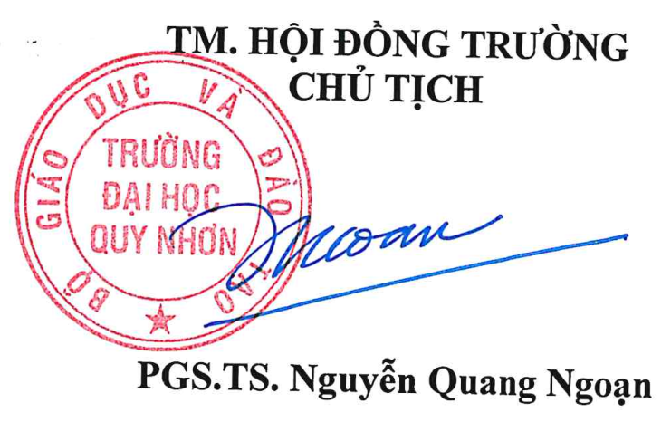

ENROLLMENT DIRECTION FOR THE YEAR 2023 OF QUY NHON UNIVERSITY
(The issuance is accompanied by Resolution No. 57/NQ-HĐT dated December 19, 2022, of the Council of Quy Nhon University)
I. REGULAR UNDERGRADUATE ADMISSIONS
1. The total enrollment quota is 5879 slots. Among them, the quota for teacher training programs based on capacity is 1874 (official quotas for each teacher training program determined by the Ministry of Education and Training).
2. Admission methods:
Method 1 (M1): The admission is based on the national high school graduation examination 2023 results.
Method 2 (M2): Admission based on high school academic records.
Method 3 (M3): Admission based on the national aptitude and reasoning test results conducted by national universities and other universities.
Method 4 (M4): Direct admission based on admission regulations.
3. Talent examination for Preschool Education and Physical Education majors: The results will be used for comprehensive evaluation in Methods 1 and 2.
4. Number of majors available for admission: 48 (refer to Appendix 1 attached), including 48 undergraduate programs, 01 high-quality accounting program, and an estimated 03 Collaborative programs with the University of Birmingham, United Kingdom, (including English Language, Information Technology, and Accounting).
5. Admission organization:
M1, M4: Participate in the admission process organized by the Ministry of Education and Training and join the Virtual Screening Group in the South. Approximately 50% of the total enrollment quota will be admitted through these methods.
M2, M3: Admission will be organized as of 2022, with online admission (if early admission methods are available). Approximately 50% of the total enrollment quota will be admitted through these methods.
6. Minimum entrance qualification:
M1: Teacher training programs follow the regulations of the Ministry of Education and Training; for other majors, the minimum qualification will be determined after the results of the national high school graduation examination are available.
M2: Teacher training programs follow the current admission regulations; for other majors, the minimum average score of 3 subjects considered for admission is at least 18.0 (including priority points according to admission regulations).
M3: Depends on the examination results conducted by the respective universities.
7. Admission fees: Follow the general regulations of the Ministry of Education and Training.
8. Tuition fees: Undergraduate programs follow Decree No. 81/2021/ND-CP; high-quality training programs are determined based on economic-technical norms.
II. ADMISSIONS FOR PART-TIME UNDERGRADUATE PROGRAMS
1. Total enrollment quota: Dependent on the regular full-time program quota: 30% of the total quota for non-teacher training disciplines; 50% of the regular quota for teacher training disciplines; enrollment quota for post-secondary programs for specified candidates (non-bidding) as stipulated in Decree 71, adjusted according to Circular 03 (if applicable).
2. Admission method is Selection-based admission according to the current admission regulations.
3. Several majors are available for admission: 26 (see Appendix 2 attached).
4. Admission organization: Multiple rounds throughout the year.
5. Minimum entrance qualification: According to the current admission regulations.
6. Admission fees: According to the university's regulations.
7. Tuition fees: According to Decree No. 81/2021/ND-CP.
III. POSTGRADUATE ADMISSIONS
1. Doctoral level:
- The total enrollment quota is estimated at 15 slots.
- Majors available for admission are Analytical Mathematics, Algebra, and Number Theory; Theoretical Physics and Physical Chemistry.
- The admission method is Selection-based admission.
- Minimum entrance qualification: According to the current regulations.
- Admission fees: According to the regulations of Quy Nhon University,
- Tuition fees: According to Decree No. 81/2021/ND-CP.
2. Master's level:
- The total enrollment quota is estimated at 1125 slots.
- Number of majors available for admission: 23 (see Appendix 3 attached), including the planned new majors: Theory and Methods of Teaching Chemistry; Finance - Banking (admissions will be conducted after completing the program establishment procedures).
- The admission method is Selection-based admission.
- Minimum entrance qualification: According to the current regulations.
- Admission fees: According to the regulations of Quy Nhon University.
- Tuition fees: According to Decree No. 81/2021/ND-CP.

